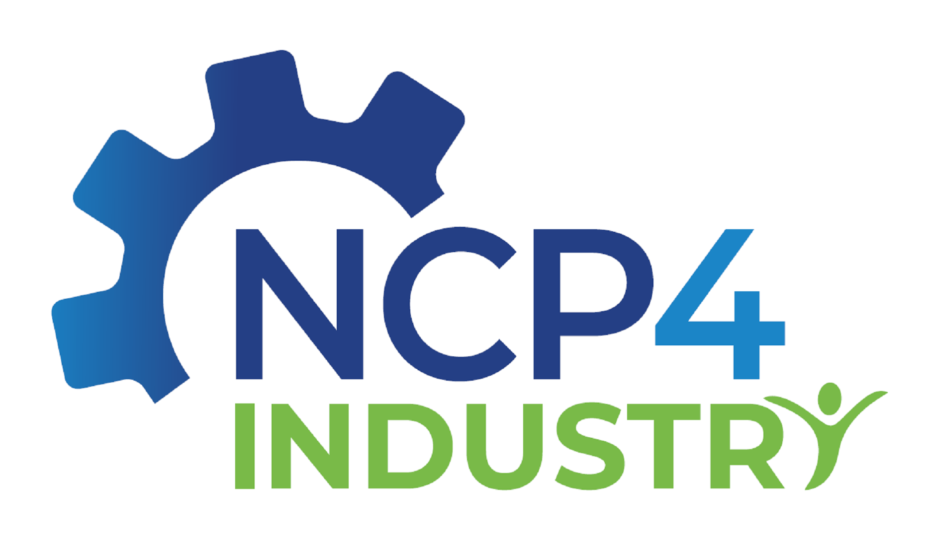

**NCP4Industry meets IAM-I**

The Horizon Europe Cluster 4 network of National Contact Points (NCPs) for Industrial Technologies ([NCP4Industry](https://ncp4industry.eu/)) and the Innovative Advanced Materials Initiative ([IAM-I](https://www.iam-i.eu/)) organise the **webinar** **“NCP4Industry meets IAM-I”** on **May 27th 2025, 10:00 – 11:30 (CET)**.

During the webinar, you will get a brief overview on the services provided by NCP4Industry for NCPs and proposers in Horizon Europe. Additionally, IAM-I will present the current state and the Strategic Research & Innovation Agenda (SRIA) of the new co-programmed European Partnership IAM4EU and how interested higher education institutions, research organisations, SMEs and larger industries can participate in the multidisciplinary network on innovative advanced materials of IAM-I.

Registration to the webinar is open until May 21st 2025 (end of business) under: *link*

**Preliminary agenda**

from 09:50 (CET) Join the webinar

10:00 (CET) Welcome and Introduction to the webinar – *tbd*, NCP4Industry

10:05 (CET) Introduction to the services offered by NCP4Industry to NCPs and proposers – *tbd*, NCP4Industry

10:15 (CET) Introduction to IAM-I and IAM4EU – Eva-Kathrin Schillinger, Secretary General IAM-I

11:00 (CET) Q&A-Session

11:30 (CET) End of the webinar

Feel free to contact the organisers Christof Haas ([c.haas@ptj.de](mailto:c.haas@ptj.de)) and Michael Wessel ([m.wessel@ptj.de](mailto:m.wessel@ptj.de)) for any questions.